Responsible Growth * NE Washington
Newsletter Update
Spring Edition 2019

HiTest/PacWest Smelter Emissions

The HiTest/PacWest 105-megawatt smelter will use Coal, Wood Chips, Charcoal and Quartz to produce silicon metal. Revised estimated annual smelter emissions, “Prevention of Significant Deterioration” (PSD) triggers: 766,131 tons Greenhouse Gases (GHG), 649 tons Sulfur Dioxide (SO2), 935 tons Nitrogen Oxides (NOx), 601 tons Carbon Monoxide (CO), 70 tons Particulate Matter (PM). Non-PSD emissions: 90 tons Volatile Organic Compounds (VOC), 0.1 tons Lead (Pb), and other coal toxins including arsenic (As) and mercury (Hg).

HEALTH IMPACTS.
SO2. Harmful effects on the lungs and respiratory system; can reduce the ability of the lungs to function.
NO2. Harmful effects on the lungs: Increased inflammation, reduced lung function, and increased asthma attacks. NO2 may be a cause of asthma in children.
PM: Small particles 10 micrometers (or less) in diameter. PM can get deep into lungs, and may also enter the bloodstream. Impacts: premature death in people with heart or lung disease, nonfatal heart attacks, irregular heartbeat, aggravated asthma, decreased lung function.
VOCs: Cancer; also linked with cardiovascular disease and poor fetal development.
Arsenic: Cancer. Lead and Mercury: neurological and behavioral disorders.

ENVIRONMENTAL IMPACTS.
Impacts include: damage to forests, wildlife, soil, air quality, and water quality due to acid rain and other contaminants from coal emissions. Thermal inversions
prevalent from early fall through spring will concentrate the toxic emissions, exacerbating negative health effects.

“Pend Oreille County doesn’t need HiTest to revitalize its economy. The smelter came to our region for its cheap electricity and strategic location. Plenty of other companies would be attracted by these attributes if we, as a community, took the time to find them.” Kalispel Tribe of Indians’ Resolution No. 2018-16

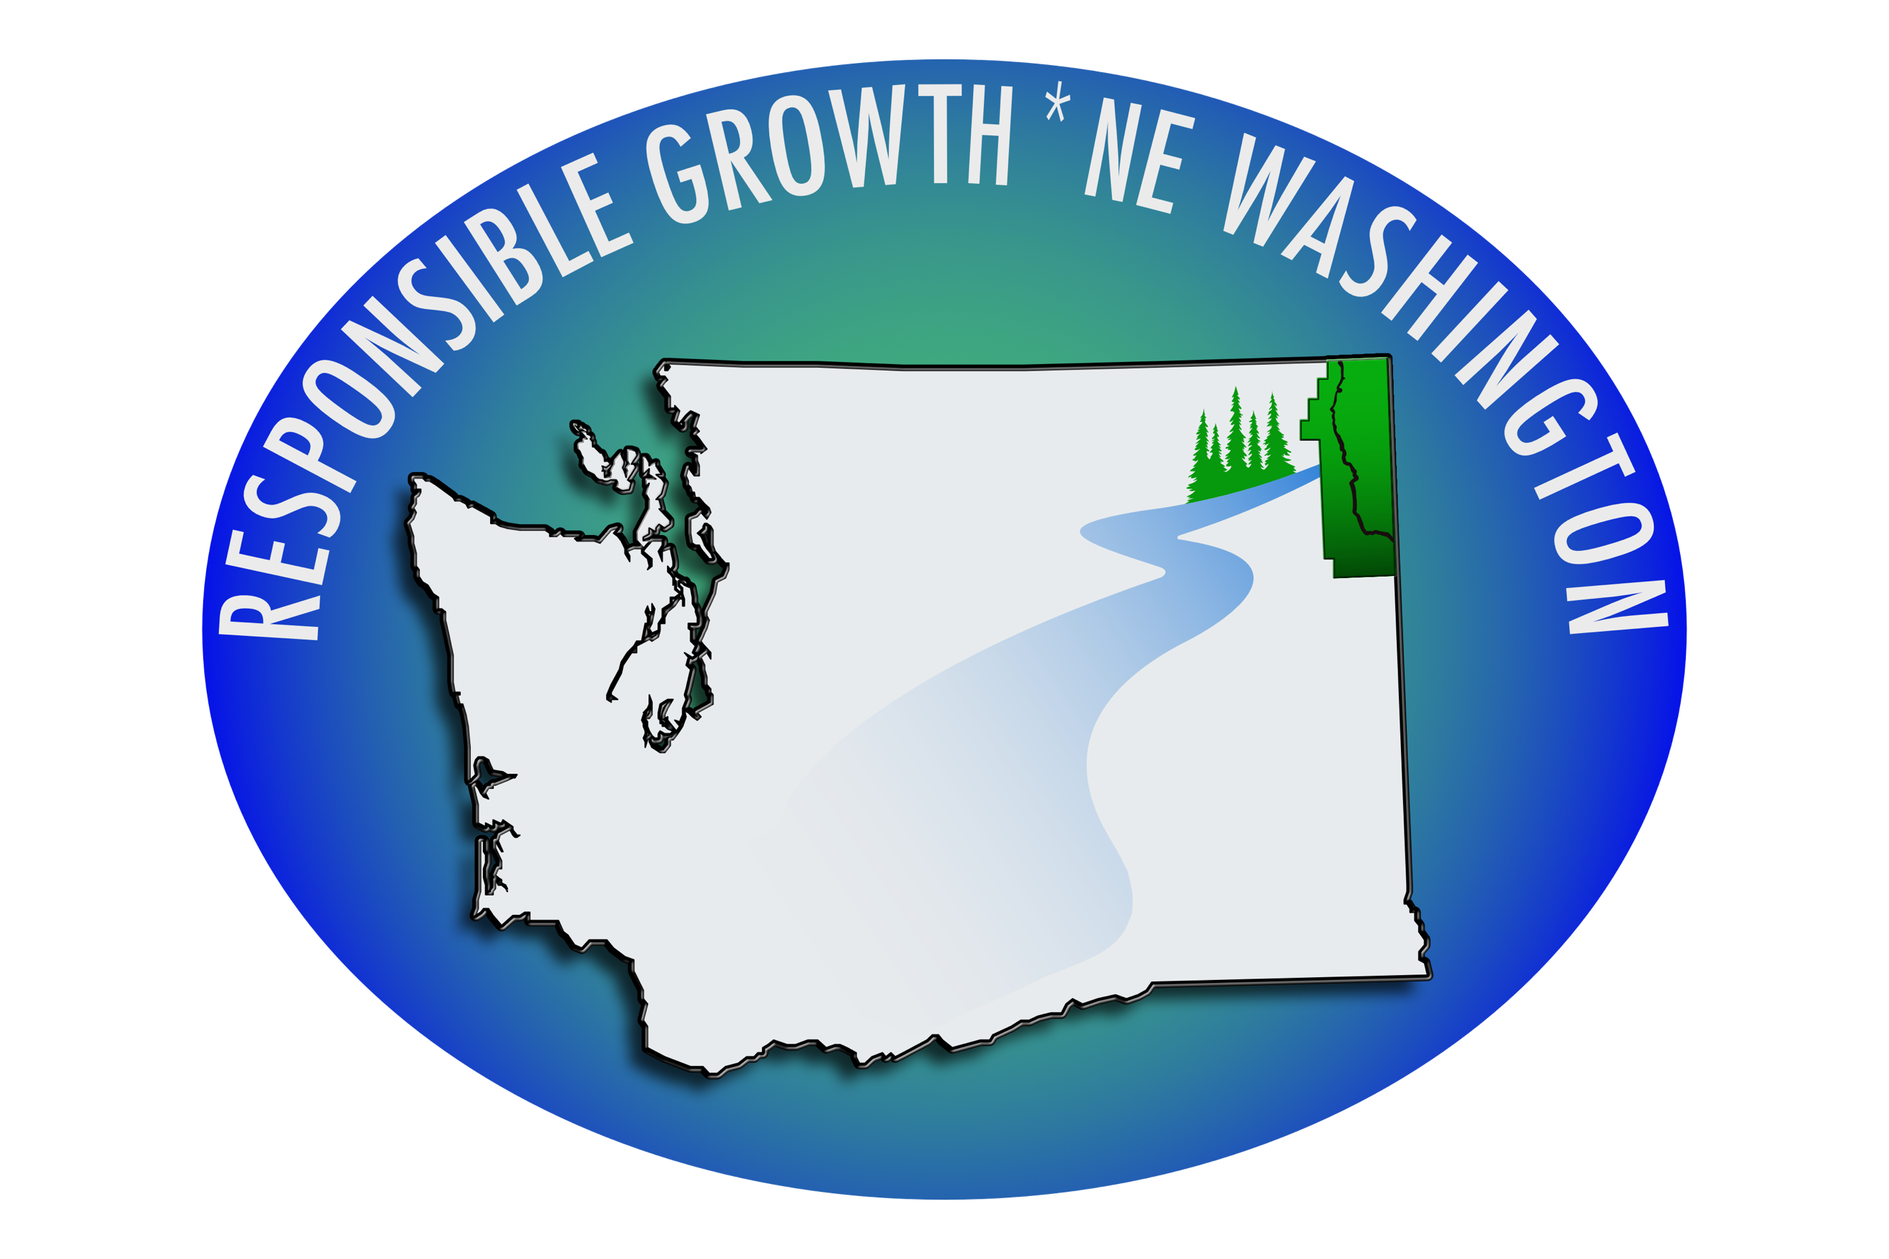
PacWest coal train and coal dust threatens our health and environment.

“Each time coal is handled (mined, transported, transloaded, or coal storage piles are disturbed), coal can break into smaller pieces, generating invisibly small particles that make up coal dust.
Some of the coal dust particles are so small that they cannot be seen without a microscope. These invisible particles, with an aerodynamic diameter less than 2.5 micrometers, are referred to as fine particulate matter (PM2.5) and are of most concern because they can be inhaled and travel deep into the human body. PM2.5 are considered the most harmful to human health.
Coal and coal dust also contain metals that are harmful to human health, including mercury, arsenic, cadmium, chromium, lead, and nickel. Many of these metals have been associated with increased risk of cancer, birth defects, genetic defects, endocrine disruption, and neurological damage. “

PacWest Project proposal for its raw materials.
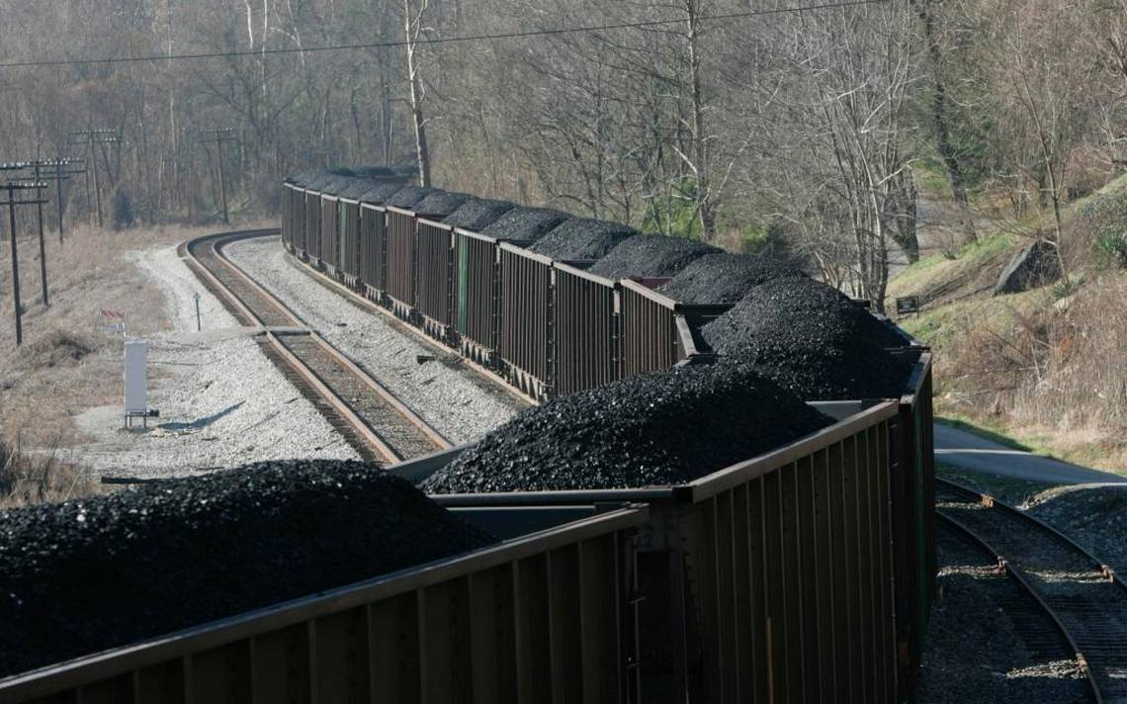
“A proposed rail spur and loop to the west of the site would connect the facility with existing tracks, and would be used to hold the trains while cars containing raw materials are unloaded.
The number of rail cars unloaded per day is expected to range between 1 and 100 …. An average of five rail cars would be loaded with products and shipped offsite each day.
Inbound and outbound rail shipments are expected to occur throughout the year. Loading and unloading activities would be covered and fugitive dust would be mitigated by suppression systems. A switching locomotive would be available on site to coordinate rail movement as needed.”

PacWest Large Polluter of GHGs
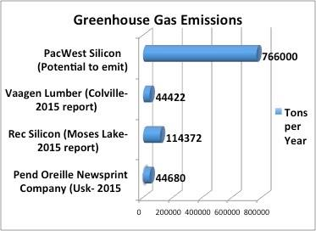

Blanket Rezone Contradicts Growth Management Act
County Commissioners’ CPU-18-POC Amendment includes blanket public land rezoning that will impact lands across approximately 2/3 of the county; and will allow more intense uses such as industrial, residential, and other development. Suspicion that CPU-18-POC will facilitate development of the proposed Newport silicon metal smelter was confirmed in a recent article in the Reader (3/29/19): “…until the county amends its Comprehensive Plan to “reform the current county zoning laws,” PacWest is unable to apply for a conditional use permit.”

From a Gonzaga University Legal Assistance Clinic letter written on behalf of RG*NEW: “The County has a duty under SEPA to fully evaluate the impacts of the maximum potential development of the property impacted by its comprehensive plan amendment, including known proposals. This must encompass the entirety of the lands impacted by the proposal. It is not enough for the County to defer analysis to some later time when a specific proposal arises – this ignores the requirement to consider the cumulative effects of the action.”

After diligent deliberation, the Pend Oreille County Planning Commission recommended to deny the blanket Public Land rezone CPU-18-POC at its April 9, 2019 meeting. County Commissioners will make a final decision at some point in the future.

Proposed Silicon Smelter Rank Among WA Industrial Polluters.
SO2 5th in state
NOx 12th in state
GHGs 17th in state
PM 10 & 2.5 12th in state

Who Are We?
Responsible Growth * NE Washington (RG*NEW) is a Washington based, nonprofit organization. Our goal is to work with Community Leaders and Citizens to foster economic growth by providing living wage jobs while sustaining our rural lifestyle and natural environment.

Read more about Our Mission and vision. Visit us on Facebook or website www.rgnew.org.
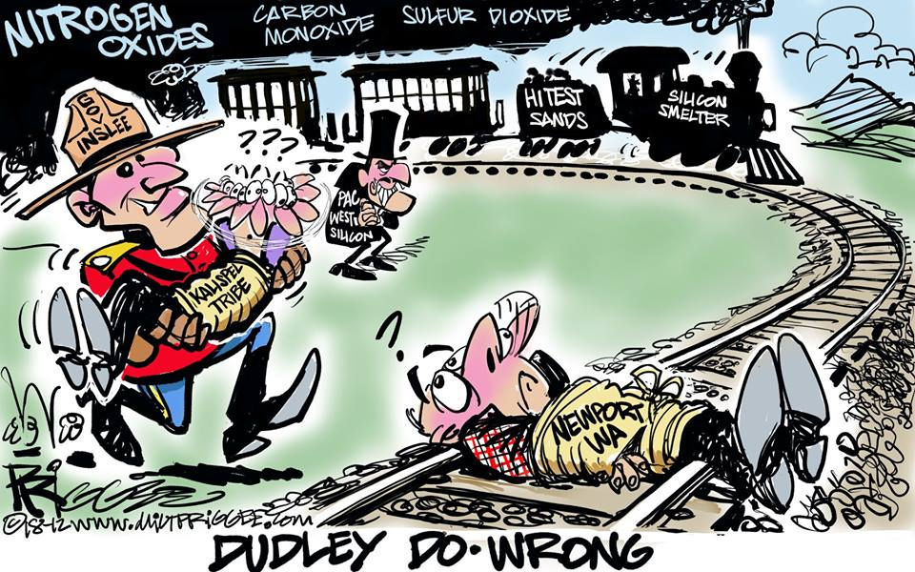

PacWest: The Facility will be a “Green Plant”
PacWest statements to The Beacon: “We are not a coal burning smelter”. “Coal doesn’t burn anywhere near the temperature needed.” “We use coal as a reductant.” “The facility will be a “green” plant, with no coal ash or smoke, and they are not feeding into any area waterways.”
“… and if the coal is burnt, it will vaporize the carbon.”
But we know that coal ignites at 750-800°F and produces toxic coal emissions (smoke) as it burns. The emissions will pollute our air, waterways, soils, and forests. The carbon from coal reduces silicon dioxide to silicon as carbon is oxidized to carbon dioxide. Carbon does not vaporize or melt—it turns into a gas (sublimes) at 6,500 °F, well above the 3,000°F plus smelter furnace.
Newsletter Informational, data and statistics sources:

- Washington State Department of Ecology
- U.S. Environmental Protection Agency
- PacWest Revised PSD Protocol
- Pend Oreille Community Development Dept.
- WA Growth Management Act
- State Environmental Policy Act (SEPA)
- Newport Miner Letter to the Editor
- The Beacon Letter to the Editor
- PacWest Project Proposal Letter to DOE
- Analysis of Health Impacts and Safety Risks Related to the Transport, Handling, Transloading, and Storage of Coal.

