PEND OREILLE COUNTY
HEARING EXAMINER

IN RE:  DETERMINATION OF NONSIGNIFICANCE AND ENVIRONMENTAL CHECKIST FOR COMPREHENSIVE PLAN AMENDMENT CPU-18-001 |  | APPELLANT RESPONSIBLE GROWTH * NE WASHINGTON STATEMENT OF APPEAL

I. INTRODUCTION

This statement of appeal is submitted on behalf of Appellant, Responsible Growth * NE Washington. The subject of the appeal is Pend Oreille County’s Determination of Nonsignificance (“DNS”) issued on May 1, 2019, and the SEPA Environmental Checklist (“Checklist”) completed on September 4, 2018, for Comprehensive Plan Amendment CPU-18-001. For the reasons set forth below and that will be presented at the hearing for this matter, Appellant urges you to remand the DNS to the County’s planning staff for the completion of an Environmental Impact Statement.
II. SUMMARY OF DNS AND CHECKLIST

The document subject to this appeal is Pend Oreille County’s DNS and Checklist for Comprehensive Plan Amendment CPU-18-001, both issued by Greg Snow, Community Development Director.
As stated in the DNS, CPU-18-001, the proposal subject to SEPA review is:
A proposal that (i) Deletes the “Public Lands” or PL zone from the Pend Oreille County Comprehensive Plan, Development Regulations and Table of Permitted Zoning Uses; (ii) Amends the Pend Oreille County Table of Permitted Uses to establish a “Public/Institutional Uses;” (iii) Amends the Pend Oreille County Development Regulations to add a definition of “Public/Institutional Uses;” and (iv) Amends the zoning and Future Land Use Map designation for those properties currently zoned and designated as “Public Lands” consistent with the criteria found in the Pend Oreille County Code Rural Lands Density Criteria Matrix set forth in Table 2.1 of the Pend Oreille County Comprehensive Plan.

DNS at 1. The Checklist states, throughout, that the proposal is “for a non-project action.” See, e.g., Checklist at 4.
CPU-18-001 would change the designation of Public Lands to designations “[c]onsistent with Rural Lands Density Criteria Matrix.” As illustrated below, CPU-18-001 would have wide-reaching and significant impacts in the County by effectively abolishing the Public Lands zoning designation, which currently accounts for over 65% of the land in the Pend Oreille County.

[INTENTIONALLY LEFT BLANK]
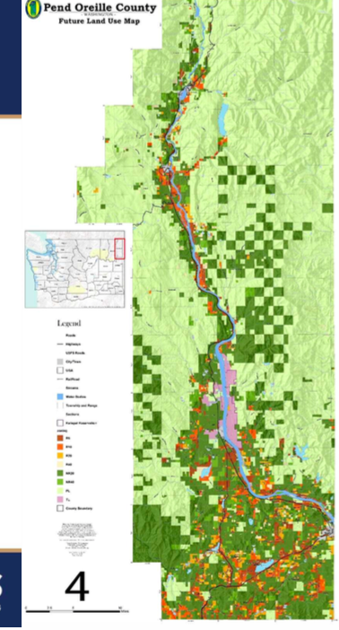
As the Pend Oreille County Future Land Use Map indicated, the areas identified in light green are impacted by this proposal.
Rather than conduct any meaningful environmental assessment and evaluation of the proposed comprehensive plan amendment. The DNS concludes, “The lead agency for this proposal has determined that it does not have a probable significant adverse impact on the environment. An environmental impact statement (EIS) is not required under RCW 43.21C.030(2)(c). This decision was made after review of a completed environmental checklist and other information on file with the lead agency. This information is available to the public on request.” DNS at 1. However, no additional information was available for review meaning that the sole basis for this conclusion was the environmental checklist.
The environmental checklist was completed by staff of the County, itself. Checklist at 2, 17. The Checklist lacks basic information including: (1) a map of the area impacted by the proposed Comprehensive Plan; (2) the parcels impacted; (3) the acreage impacted; and (4) a description of parcels that are currently in private ownership that may be impacted by the proposal. See generally Checklist. A review of the checklist indicates that no level of analysis of any impacts was provided. In fact, a majority of the checklist questions were answered by stating, “This application is for a non-project action. Environmental elements for specific projects on specific properties will be identified at the time of land use application.” Id. This was the case for all or a great portion of the sections of the checklist addressing earth, air, water, groundwater, plants, animals, energy and natural resources, environmental health, noise, land and shoreline use, housing, aesthetics, light and glare, recreation, historic properties, transportation, public services, and utilities. Id. The remaining portions of the checklist either generically refer to existing zoning code and development regulations, fail to provide any discussion of any impacts, or provide a cursory description of impacts without any specific discussion of each properties current condition and the changed condition that will likely occur as a result of the comprehensive plan amendments. Id.
The Checklist fails to discuss other pending Comprehensive Plan amendments pending before the County, some impacting parcels currently designated as public lands. Id. The Checklist also lacks any discussion of proposed projects that are dependent upon the comprehensive plan in order to proceed. Id.
As provided below, the failure of the County’s own checklist coupled with the DNS amounts to a violation of SEPA warranting remand and a completion of an EIS.
III. REQUIREMENTS OF SEPA

SEPA environmental review is required for any local agency decision that is not categorically exempt, including, as here, amendments of a County comprehensive plan. WAC 197-11-704(b)(ii). Rather than conduct any detailed environmental analysis, the County essentially deferred all environmental review to later and unspecified time. The DNS and the checklist do not present any assessment of the environmental impacts associated with the Amendment, which will impact a vast majority of the County. It is simply not logical or legal to completely defer analysis to some unspecified time. Impacts cannot be segmented out to avoid full disclosure of impacts.
SEPA requires the disclosure and full consideration of environmental impacts in governmental decision making. Polygon Corporation v. Seattle, 90 Wn.2d 59, 61 (1978), citing Norway Hill Preservation & Protection Ass'n v. King County Council, 87 Wn.2d 267 (1976). The Court of Appeals in Moss v. Bellingham restated the long-standing rule that the purpose of SEPA is to function “as an environmental full disclosure law.” 109 Wn. App. 6 (2001). Agency decisions must consider more than the narrow, limited environmental impact of the immediate, pending action and cannot close their eyes to the ultimate probably environmental consequences. Cheney v. Mountlake Terrace, 87 Wash.2d 338, 344 (1976). SEPA specifically required that the County conduct a detailed and comprehensive review, rather than take a “lackadaisical approach”, as occurred here. Eastlake Cmty. Council v. Roanoke Assocs., Inc. 82 Wn.2d 475, 494 (1973); see also Norway Hill Pres. & Prot. Ass’n v. King County, 87 Wn.2d 267, 273 (1976) (SEPA requires a “detailed statement”).
SEPA further requires the County to demonstrate environmental impacts were considered in a manner sufficient to amount to prima facie “compliance with the procedural requirements of SEPA.” Sisley v. San Juan County, 89 Wn.2d 78, 64 (1977).
SEPA regulations specifically require that the County “carefully consider the range of probable impacts, including short-term and long-term effects” of a proposal. WAC 197- 11-060(4)(c). Moreover, the regulations specifically state:
A proposal's effects include direct and indirect impacts caused by a proposal. Impacts include those effects resulting from growth caused by a proposal, as well as the likelihood that the present proposal will serve as a precedent for future actions. For example, adoption of a zoning ordinance will encourage or tend to cause particular types of projects or extension of sewer lines would tend to encourage development in previously unsewered areas.

WAC 197-11-060(4)(d).
While the law provides some flexibility in the level of detail necessary in the review of a nonproject action, see e.g. WAC 197-11-442(2), there is nothing that authorizes the County to turn a blind eye to all environmental impacts and to “punt” analysis to some later and unidentified process. The Growth Management Hearings Board (“Hearing Board”) has stated, “It is clear that an amendment to the Comprehensive Plan …requires environmental review.” Superior Asphalt and Concrete v. Yakima County, Case No. 05- 1-0012, Final Decision and Order (June 20, 2006). Moreover, Washington’s State Environmental Policy Act Handbook specifically provides that the review of comprehensive plan amendment should include consideration of the future development allowed by that action, stating:
If the nonproject action is a comprehensive plan or similar proposal that will govern future project development, the probable impacts need to be considered of the future development that would be allowed. For example, environmental analysis of a zone designation should analyze the likely impacts of the development allowed within that zone. The more specific the analysis at this point, the less environmental review needed when a project permit application is submitted.

Washington Department of Ecology, State Environmental Policy Act Handbook (2003) at 66 (hereinafter referred to as the “SEPA Handbook”).
Here, the County made no effort to analyze the probable impacts of its proposed comprehensive plan amendment. Instead, the checklist and DNS defer virtually all analysis of impacts to some future, unidentified time.
The SEPA Handbook further states, in regards to actions such as this governed by the Growth Management Act (“GMA”), “It is not possible to meet the goals or requirements of GMA or to make informed planning decisions without giving appropriate consideration to environmental factors. The GMA nonproject actions such as the adoption of policies, plans, and regulations form the basis for subsequent “on the ground” project decisions that directly affect our environment.” SEPA Handbook at 75. The guidance in the SEPA Handbook could not be any clearer to this situation:
Q: Is environmental review necessary for a jurisdiction that is updating an existing comprehensive plan to satisfy GMA?

A: Yes, updating an existing comprehensive plan is an action that requires environmental review under SEPA. The type of environmental review required will vary depending on whether an EIS was prepared for the existing plan, how recently the EIS was prepared, and how extensive the revisions will be. As a general rule, the environmental review should address any probable significant adverse impacts that will result from the revised plan that were not analyzed when the existing plan was adopted.

SEPA Handbook at 131. No prior EIS or SEPA document covers the action subject to the challenged DNS.
Hearings Board cases addressing SEPA requirements in GMA actions consistently mirror the requirements of the SEPA Handbook. For example, in Better Brinnon Coalition v. Jefferson County, Case No. 03-2-0007, Amended Final Decision and Order (Nov. 3, 2003), the Western Growth Management Hearings Board stated:
Petitioner alleges that this SEIS is inadequate because it defers too much of the analysis of environmental impacts to the project stage when actual development proposals will be presented, and because it fails to address particular environmental concerns. The County directs our attention to WAC 197-11-442 which provides that the County shall have “more flexibility in preparing EISs on nonproject proposals”. However, the flexibility afforded the County is not unlimited. All environmental documents prepared under SEPA require consideration of environmental impacts, with attention to impacts that are likely, not merely speculative. WAC 197-11-060 (4).

…

We note with the County's hearing examiner that the County essentially chose to defer all environmental review until the permitting stage. … This is a pattern that the hearing examiner notes leads to a “dangerous incrementalism” whereby the environmental issues are never really addressed. Ibid. This is neither proper phasing nor a proper use of flexibility in setting the detail of analysis. The County must evaluate the environmental impacts that are probable as a result of the change proposed. Those impacts should be measured in terms of the maximum potential development of the property under the changed land use designation. See Ullock v. Bremerton, 17 Wn. App. 573, 575, 565 P.2d 1179 (1977). By waiting until each permit application is presented, the County would be unable to assess the cumulative impacts of the increased development in any meaningful way and would thwart the aim of providing future permit applicants with certainty about what is allowed in the Brinnon Rural Village Center and WaWa Point SRT overlay.

In Hood Canal v. Jefferson County, Case No. 03-2-0006, Final Decision and Order (Aug. 15. 2003), the Hearings Board struck down a similar effort of Jefferson County to defer evaluation of environmental impacts because the proposed action was a nonproject comprehensive plan action, stating:
The County argues that the review that was conducted at this stage was appropriate because the County has flexibility in preparing an EIS and a general discussion of the impacts of alternate proposals is proper because the comprehensive plan affected a land use designation. WAC 197-11- 442(1) and (4). However, this regulation does not excuse the County from an analysis and evaluation of environmental impacts of alternatives; it just means that the impacts and alternatives may be discussed “in the level of detail appropriate to the scope of the nonproject proposal and to the level of planning for the proposal.” WAC 197-11-442(2).

Likewise, the Hearings Board in Seaview Coast Conservation Coalition v. Pacific County, Case No. 96-2-0010, Final Decision and Order (Oct. 22, 1996), also rejected the approach implemented here:
The record also reflected that the County did not address issues concerning access, utilities, fill for septic sewage systems nor the cumulative impact that those necessary residential aspects would impose on the area covered by the amendment. …

The record also raised issues concerning the erosion/accretion controversy, whether stabilization measures to prevent single family residences from being covered by sand or exposed to wave action would impact or damage fish and wildlife habitat and whether the area was a geologically hazardous area because of prior history of tsunami events and potential future events. The record reflected that the County's response to the environmental issues was to ignore them totally, disregard them as being unsubstantiated or acknowledge their existence but postpone any analysis until a later unspecified time. …

WAC 197-11-060(4)(c)(d) requires that environmental consideration of a non-project nature include a “range of probable impacts”. We have a firm conviction that a mistake was made in the County's DNS decision. This record is replete with unanswered questions about the environmental impacts of this proposal, the segregated nature of the consideration of MP and zoning amendments and the likelihood that such analysis if not done now will never be. Pacific County is not in compliance with the GMA as it relates to SEPA by the DNS that was entered in this case.

While SEPA does not require the County to evaluate a laundry list of unrelated environmental considerations, it does require that the County evaluate probable significant environmental impacts. WAC 197-11-402 (1). Here, the County made no effort to look the impacts of the comprehensive plan amendment as required by SEPA.
Moreover, SEPA requires that hearings on a proposal, even if conducted under another authority. WAC 197-11-535(1) states, “If a public hearing on the proposal is held under some other requirement of law, such hearing shall be open to consideration of the environmental impact of the proposal, together with any environmental document that is available.” Here, the County Planning Commission specifically prohibited testimony related to environmental impacts of the Comprehensive Plan proposal when it prohibited testimony regarding a known and proposed land use for several impacted parcels.
IV. REASONS AND GROUND FOR APPEAL.

The evidence and testimony presented at the hearing by Appellant will demonstrate the following:
- The DNS and Checklist failed to Disclose or Consider Environmental Impacts of the Comprehensive Plan Amendment.

SEPA regulations require the County to “carefully consider the range of probable impacts, including short-term and long-term effects” of a proposal. WAC 197-11-060(4)(c). Here, the County has failed to consider any of the impacts of amending the Comprehensive Plan. The SEPA checklist merely states that specific projects will be reviewed in the future, despite significant changes that will be permitted as a result of the amendment.
Evidence presented at the hearing will demonstrate that the DNS and Checklist failed to consider the environmental impacts associated with CPU-18-001. This proposal impacting over 2/3 of the County has not been properly analyzed by the County as evidenced in the SEPA checklist answers–or rather, lack of substantive answers. Significant and widespread environmental impacts will be associated with the changes associated with this proposed amendment.
For example, as indicated by the current Table of Permitted Zoning Uses included below, lands that are designated “Public Lands” do not allow for industrial or mining uses. On “Public Lands” there could be no Master Planned Resorts, Multi-Family Housing, Recreational Vehicle Parks, or Single-Family Dwellings.
As the proposed revised chart indicates, CPU-18-001 would either permit these uses or make these uses permitted through the issuance of a conditional use permit by shifting “public lands” to “rural land” designations. Widescale development consistent with a “rural land” designation is significantly more intensive than the current and restrictive “public lands” designation. These changes were not disclosed or analyzed in the DNS or the Checklist.
Moreover, as proposed Note 4 (above) indicates, public and institutional uses are permitted across all uses – this is a significant departure from the previous “public lands” designation, which contained significant restrictions regardless of ownership. Again, this was not disclosed or analyzed in the DNS or the Checklist. The County must analyze the maximum potential development associated with this proposal.
- The DNS and Checklist failed to Disclose or Consider Development of the Proposed Newport Smelter.

As stated above, SEPA regulations require the County to “carefully consider the range of probable impacts, including short-term and long-term effects” of a proposal. WAC 197-11-060(4)(c). Here, the County has failed to consider any of the impacts of amending the Comprehensive Plan, particularly development of the proposed PacWest Newport Smelter, which would be allowed to proceed if this amendment is adopted.
Evidence presented at the hearing will demonstrate that CPU-18-001 would facilitate the development of PacWest’s smelter and that the DNS and Checklist failed to disclose or analyze impacts associated with the smelter development. In fact, the proponent of the smelter recently stated publicly:
While working with the state on its options, the company has also been coordinating with Pend Oreille County, as the site purchased for the smelter is currently zoned as public land. That needs to change before the other work can move forward, Tymko says.

The proposed smelter is on land that is designated Public Lands (see images blow) and thereby not currently available for industrial use, under the current designation.

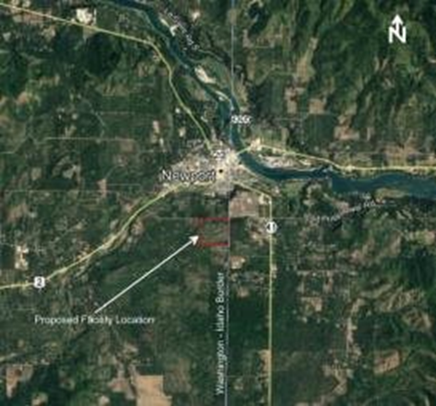

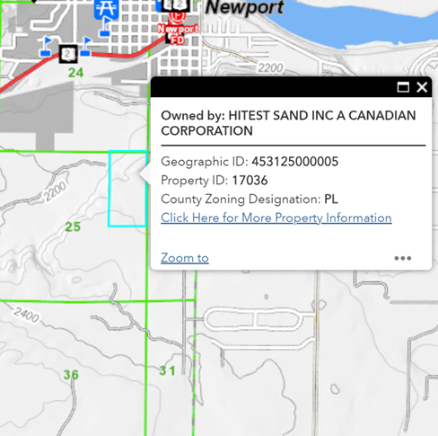
The County has a duty under SEPA to fully evaluate the impacts of the maximum potential development of the property impacted by its comprehensive plan amendment, including known proposals. This must encompass the entirety of the lands impacted by the proposal. It is not enough for the County to defer analysis to some later time when a specific proposal arises – this ignores the requirement to consider the cumulative effects of the action.
- The DNS and Checklist failed to Consider the Cumulative Effects of the Other Proposed Comprehensive Plan Amendments.

Evidence and testimony presented at the hearing will demonstrate that the DNS and the Checklist failed to disclose or analyze any cumulative impacts of other pending comprehensive plan amendments, including amendments that would redesignate public lands. The County has a duty under SEPA to take a look at what the cumulative impacts of its proposals are. Cheney v. City of Mountlake Terrace, 87 Wash.2d 338, 344 (1976) (“Implicit in [SEPA] is the requirement that the decision makers consider more than what might be the narrow, limited environmental impact of the immediate, pending action. The agency cannot close its eyes to the ultimate probable environmental consequences of its current action.”). Specifically, WAC 197-11-330(3) requires that the County “take into account” whether “several marginal impacts when considered together may result in a significant adverse impact.” This simply did not occur.
The SEPA Handbook clearly provides that the County should evaluate cumulative impacts of development through the comprehensive plan amendment process:
Q: How and when are cumulative impacts evaluated?

A: SEPA requires agencies to address cumulative impacts. This can be difficult if each project is evaluated individually in isolation from other related proposals. With comprehensive planning under GMA, cities and counties are able to look at the “big picture,” evaluate cumulative impacts of development, and determine appropriate mitigation measures to apply to individual, future proposals. Agencies also have a responsibility to look at cumulative impacts within project EISs. The EIS should look at how the impacts of the proposal will contribute towards the total impact of development in the region over time.

SEPA Handbook at 131-32.
The cumulative impacts of all of the County’s comprehensive plan amendments need to be disclosed, analyzed, and mitigated.
- The Checklist lacks Basic Information about the Proposal.
Evidence and testimony presented at the hearing will demonstrate that the primary document relied upon by the County in issuing the DNS, the SEPA Checklist, did not disclose potential areas of impact associated with the proposal and lacked, even basic information about the proposal. The purpose of the SEPA checklist: “is to provide the information to . . . the agency, identify impacts . . . and to help the agency decide whether an EIS is required.” WAC 197-11-960. The County did not discuss or disclose several significant issues on the checklist, which in turn, were not considered or evaluated in the DNS. Here, the SEPA checklist is filled with inadequate boilerplate answers to nearly every question -- “This application is for a non-project action. Environmental elements for specific projects on specific properties will be identified at the time of land use application.” See generally Checklist.
Of the 108 questions on the Checklist, the County managed to use this boilerplate language on 80 of them - 74% of the Checklist. On the Supplemental Sheet for Nonproject actions part of the SEPA checklist, the County failed to include any information about the proposed Newport Smelter or any other activities that would be allowed under the new amendment that had previously been restricted. SEPA environmental review is required for any local agency decision that is not categorically exempt and here, the County is not categorically exempt when amending the Comprehensive Plan. WAC 197-11-704(b)(ii).

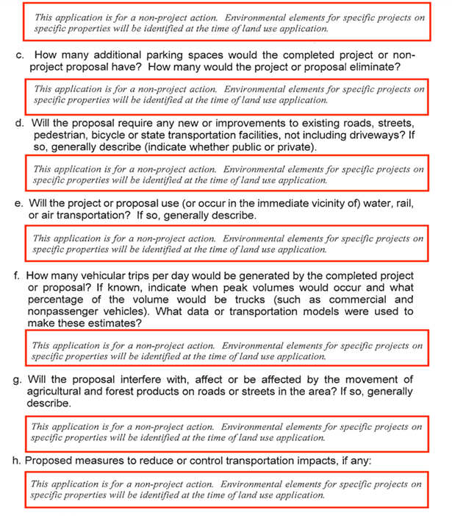

The Checklist lacks even basic information about the proposal that would allow the public to investigate potential impacts, including: (1) a map of the area impacted by the proposed Comprehensive Plan; (2) the parcels impacted; (3) the acreage impacted; and (4) a description of parcels that are currently in private ownership that may be impacted by the proposal. See generally Checklist. SEPA regulations and procedures are designed to evaluate project impacts and prevent environmental harm, not simply rubber stamp an attractive proposal. This amendment has not been properly analyzed as evidenced in the Checklist answers–or rather, their lack of substantive answers.
- The Planning Commission violated SEPA requirements for Public Participation.

Evidence and testimony presented at the hearing will demonstrate that the County failed to comply with public participation requirements of SEPA. During the public comment portion of the Planning Commission meeting for CPU-18-001 at the Cusick Community Center on January 8, 2019, the Chair restrained some members of the public from using the word “smelter.” This was the only public hearing on the proposal before the Planning Commission.
The Chair’s restraint on speaking the word “smelter” at the Planning Commission meeting violated SEPA. To minimize the adverse environmental effect of certain actions, SEPA provides a process that must be followed to ensure that all actions are carefully considered and potential impacts identified prior to the implementation of the action. RCW § 43.21C.010. Under SEPA, if a public hearing on a proposal is held “under some other requirement of law,” then “such hearing shall be open to consideration of the environmental impact of the proposal, together with any environmental document that is available.” WAC § 197-11-535 (emphasis added).
Here, the January 8, 2019, Planning Commission meeting was subject to the mandates of SEPA because CPU-18-001 is subject to SEPA review. Accordingly, the Planning Commission meeting must “be open to consideration of the environmental impact of the proposal . . ..” Put differently, the Planning Commission meeting was required to be “open to consideration of the environmental impact” that the proposed smelter may have on the community. WAC § 197-11-535. Therefore, by restraining the public from mentioning the word “smelter,” the Chair effectively refused to consider the potential environmental impacts that the proposed smelter may have on the community. Thus, the Chair violated SEPA.
IV. CONCLUSION
Washington regulations provide that “[a]n environmental impact statement (EIS) must be prepared for all proposals with probable significant adverse impacts on the quality of the environment.” WAC 197-11-960. An EIS is required “whenever more than a moderate effect on the quality of the environment is a reasonable probability.” Sisley v. San Juan County, 89 Wash.2d 78, 85 (1977). Agencies must be able to show, when making the initial threshold determination, that the various environmental factors were adequately considered in their decision not to require an EIS. Id. at 84.
As discussed above and as will be demonstrated on the hearing in this matter, the information and analysis in the DNS and Checklist is inadequate. Given the scope of this proposal, it is more than probable that there will be a more than a moderate impact on the environment justifying the completion of an EIS. Accordingly, Appellant requests an order remanding the DNS and Checklist for CPU-18-001 with direction to the staff to complete a full and adequate EIS.
DATED this 14th day of May, 2019.
UNIVERSITY LEGAL ASSISTANCE
By:
RICK EICHSTAEDT, WSBA #36487
Attorney for Responsible Growth *NE Washington

See Pend Oreille County Comprehensive Plan Amendment Application Overview at 4. Available at: https://pendoreilleco.org/wp-content/uploads/2018/09/CPU-18-POC.pdf
Available at https://fortress.wa.gov/ecy/publications/documents/98114.pdf.
See Pend Oreille County, Table of Permitted Zoning Uses. Available at: http://pendoreilleco.org/wp-content/uploads/2016/08/Adopted-Zoning-TOPU-12-22-15.pdf
If CPU-18-001 is adopted, areas currently zoned as Public Lands and would be rezoned as designations based on the “Rural Lands Density Criteria Matrix” in the county’s Comprehensive Plan. Under that analysis, all of these public lands will be designated as Rural-5, Rural-10, Rural-20, or Rural-40 based on their density, and relation to a road system.
See https://www.inlander.com/spokane/an-environmental-study-for-the-proposed-pacwest-silicon-smelter-is-on-hold-but-company-leaders-say-its-not-due-to-market-woes/Content?oid=17585163.

