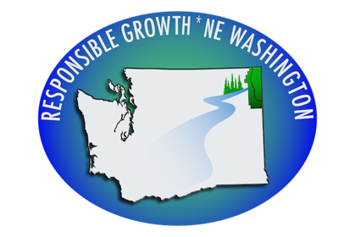
Responsible Growth * NE Washington Disappointed in Hearing Examiner Decision and Pledges to Continue Appeals
NEWPORT, WA — Today, representatives of Responsible Growth * NE Washington (RG*NEW) received the decision from the Pend Oreille County Hearing Examiner David Hubert denying the group’s appeal of the State Environmental Policy Act (SEPA) documents for a sweeping comprehensive plan and zoning change proposed by Pend Oreille County that would impact two-thirds of the County and open the door for approval of the smelter proposed by the Canadian corporation, PacWest. The land use action would abolish the “public lands” designation for the County and redesignate much of the land as “rural” allowing for significant more development in those areas.
“During an all-day hearing, RG*NEW presented expert witnesses, extensive documentary evidence, and case law that all pointed to the responsibility of the County to analyze the impacts of its actions to lands across the County, including its legal responsibility to consider the impacts of the smelter,” said Rick Eichstaedt, attorney from the Gonzaga Environmental Law and Land Use Clinic who represented RG*NEW in this matter. “Unfortunately, the hearing examiner’s decision appears largely as an effort to rubber stamp the County decision without any meaningful examination of the law or facts.”
RG*NEW’s appeal focused largely on the duty of the County under SEPA to consider the “maximum potential impact” of lands impacted by the County’s land use proposal. Instead, the County deferred analysis indicating that its action was a “non-project action” and failing to discuss the impacts. Both State court and Growth Management Hearings Board decisions have repeatedly rejected this approach to SEPA. The Hearing Examiner’s decision found, in part, that the land use proposal was not “interdependent” with the smelter and that the County was not required to consider impacts.
RG*NEW also appealed the actions of the Pend Oreille County Planning Commission limiting discussion of the smelter and its impacts at its hearing on the proposed land use action. SEPA requires that all hearings of a land use proposal include consideration of environmental impacts. The Hearing Examiner’s decision found that subsequent opportunities to provide written comment was sufficient.
“While we are disappointed with the County’s decision, we remain committed to taking whatever action is necessary to ensure that the County follows the law and that the smelter is not built in our community,” said Phyllis Kardos, co-chair of RG*NEW. “We will appeal this decision to the Growth Management Hearings Board if and when the County Commissioners approve the comprehensive plan amendment.”
Washington’s Growth Management Hearings Board is responsible for the review of all comprehensive plan amendments and supporting SEPA decisions. The Hearings Board’s decision may be appealed to Superior Court. Adverse decisions from the Hearings Board can result in the loss of state grant funds while a local jurisdiction addresses the shortcomings of its actions.
“The community is overwhelmingly against the development of this polluting smelter,” said Kardos. “The County has neglected its duty to its citizens to be honest about the impacts of the smelter and the impacts of this amendment. SEPA is about disclosure of environmental impacts early in the process – it’s not about ignoring impacts of a project until it is too late.”

For questions, please contact: Rick Eichstaedt, Attorney, Gonzaga Environmental Law
and Land Use Clinic, 509.251.1424

Phyllis Kardos, Co-Chair, Responsible Growth * NE Washington, 509.447.7958

