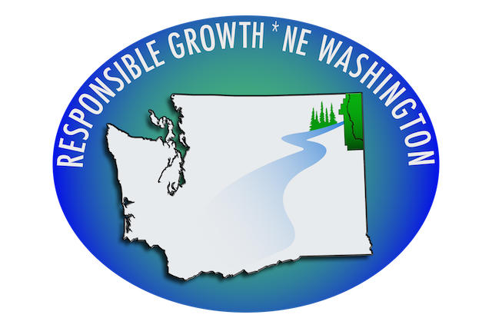

IMMEDIATE PRESS RELEASE
Monday, Dec. 9, 2019

Responsible Growth * NE Washington Applauds by the POC Commissioners’ decision to reject Comprehensive Plan Amendment to Redesignate all Public Lands to Rural.

NEWPORT, WA – Today, December 9th, the Pend Oreille County Commissioners rejected the proposed Comprehensive Plan Amendment, CPU-18-001, which would eliminate the “public lands” designations for 62-65% of land in the County. This amendment would have redesignated these areas as “rural lands,” which would have opened the door for heavy industrial use outside of Urban Growth Areas in the County, opening the door for the PacWest smelter.

“RG * NEW is cautiously optimistic that the County’s rejection of CPU-18-001 will forever shut the door on PacWest Silicon $350 million proposed silicon smelter and discourage other heavy, urban, industrial facilities from attempting to locate in our rural area,” said Phyllis Kardos, co-chair of RG * NEW. “We are being cautious due to the fact that the County is changing its current Land Use Map in the Comprehensive Plan 2020 update and eliminating all Public Lands’ designation. The draft Land Use Map is listing the PacWest properties as ‘rural.’ We have yet to see a draft Zoning Map.”

“In the event that the County’s Planning Commission recommends to the Commissioners the approval of the Comprehensive Plan 2020 Update with the draft Land Use Map, which should take place the summer of 2020,” said Kardos, “RG * NEW will undertake the same legal action that under SEPA an Environmental Impact Statement would be required for such a large rezone and especially a rezone that would sit an already proposed industrial silicon smelter.”

Responsible Growth * NE Washington would like to thank the County Commissioners at this point in time for their due diligence in listening to the majority opinion on the silicon metal smelter and in deliberating and coming to the only possible decision.

Phyllis J. Kardos
1.509.447.7958

