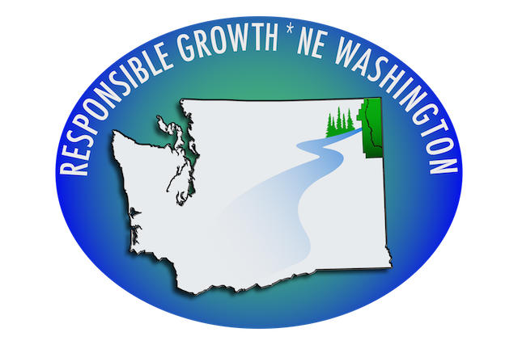
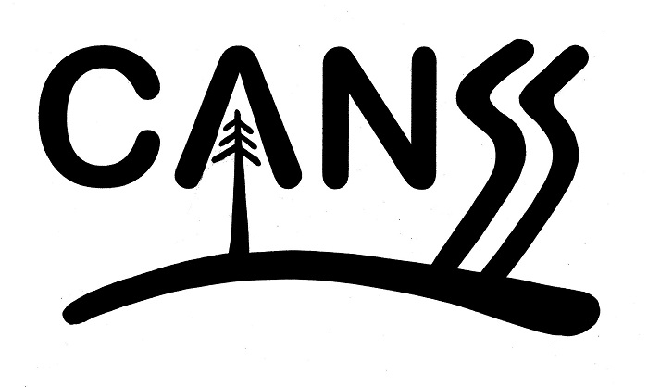
POB 960, Newport, WA 99156 POB 1347, Newport, WA 99
www.rgnew.org www.canss.org

January 14, 2020

Pend Oreille County Planning Commission
POB 5066
Newport, Washington 99156-5066

Dear Planning Commission Members,

Subject: Comments and questions regarding the Pend Oreille County Comprehensive Plan 2020 update to the Public Lands designation to a Rural designation as indicated on the latest Draft Natural Resources map, plus other questions and concerns.

Responsible Growth * NE Washington (RG * NEW) and Citizens Against Newport Silicon Smelter (CANSS) are deeply concerned that we are back where we started with the public land use designation and SEPA issues, which includes the PacWest properties currently under litigation.
The November 12, 2019, GIS Memo containing the new draft future land use designations (and map) administratively discontinues and reclassifies all current Public Lands (PL) under one of the proposed land use designations.

Citizens strongly voiced their disapproval of the County Commissioners Public Lands Amendment CPU-18-001, which would have redesignated all public lands; and, after diligent consideration and discussion, the County Planning Commission in April 2019, made the recommendation to the County Commissioners to reject CPU-18-001. The County Commissioner accepted the recommendations of its Planning Commission and rejected its own amendment. However, with the draft Comprehensive Plan 2020 update, we are once again facing a total redesignation of the County’s Public Land without a SEPA to determine the potential environmental impacts of the proposed PacWest silicon metal smelter. Once again RG * NEW and CANNS are expressing strong disapproval; it is not acceptable to us.

As indicated on the draft Land Use Map, the PacWest properties are now classified as Rural, even though those properties are Natural Resource Lands by their very nature. The larger pieces of properties adjacent to and west/south of the PacWest properties are listed as Natural Resource Lands. Why the difference in classification? Did you reclassify all Public Lands as Rural? What criteria did you use? Who made the decision and why?

On another issue, since the county has failed to provide the information, we are preparing our own descriptive analysis for each of the 201 parcels now owned by Pend Oreille County and zoned PL in the 2015 Comprehensive Plan. While not yet complete, that analysis is already documenting good reasons to keep the PL designation in the 2020 Comprehensive Plan update.

Until that time a descriptive analysis of of each piece is made available for study by the Planning Commission and the public, the Commission should reject any attempt by the county to rezone all Public Land.

Futurewise on May 22, 2019, sent a letter to the Pend Oreille County Planning Commission via the Community Development Department. We assume you received it. The concerns that Futurewise expressed about the blanket redesignation of CPU-18-001 are consistent with the concerns of RG * NEW and CANSS, which are now being include in the draft Comprehensive Plan 2020 update. We are including the Futurewise letter as part of this packet as it reflects our concerns as well.

We are inviting the Planning Commissioner members to please think through these questions we are providing and request answers from Whitebluffs Consulting and POC Community Development Department. These are critical questions that need answers. They are in no particular order.

- On the draft Natural Resouce map we see a net loss of 14,000 acres. Why do we have this net loss? Where did those acres go?

- Who were the experts and professionals that helped make the decisions concerning the draft land use maps? What are their experiences, education and qualifications?

- How is the Conservation District program being impacted by the land use changes? Were they contacted? Was their expertise used?

- Is all agricultural land and forestland in the county being rezoned? How will this change their land use status? Were private property owners in the Agricultural and Forestland programs contacted about the proposed changes? How will they be notified or will they be notified?

- What department performed the road analysis for the Rural designation? When was it done? Where is the data?

- How much Agricultural and Forest Land is being lost in the draft land use map? We need more Agricultural and Forest Land, not less.

- Why were the agricultural and forest resource lands designated to greater than 10 acres?

- Have you mapped the Wildland Urban Interface when making the land use category.

- What provisions have been made for the WIRA 55 restrictions and water exempt wells? What were the sources used? Where is the data?

- How is the Volunteer Stewardship Program being impacted? Protection Plan? Are those individuals who are in the program being kept informed?

- How are Trust lands and Conservancy lands being identified on the land use maps.?

- Why has the Comp Plan 2020 update failed to include a section on global warming and climate change? Responsible Growth * NE Washington provided an excellent section in its amendments on responding to global warming and climate change. We would encourage you to consider it for inclusion.

In summary, CANSS and RG * NEW have grave concerns that this extensive Comp Plan 2020 update is being rushed and too many vital issues and components are being overlooked or just left out of the update. There has not been enough time, nor will there be enough time to address them all adequately.

We sincerely hope the Planning Commission recognizes RG * NEW and CANSS as responsible resources and as partners in developing this document. We have the same interest as the Commission members in creating a working document that meets all the legal requirements of the Growth Management Act and that works for everyone, plus protects our agricultural lands, forest lands, and open spaces.

____________________________ ________________
Michael Rodden, CANSS Date

____________________________ _________________
Phyllis J. Kardos, RG * NEW Date

